Chapter 19, Problem 15.

For the two-port circuit in Fig. 19.76,

- Find Z_{L} for maximum power transfer to the load.
- Calculate the maximum power delivered to the load.

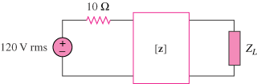

Figure 19.76
For Prob. 19.15.

